RAILWAY TICKET RESERVATION AND
JOURNEY MANAGEMENT SYSTEM

Submitted by:
SPANDAN RANA: 25WU0801009
Section: BCA TIGERS

DATABASE MANAGEMENT SYSTEM
(Course code: 25TU01MLM2)



Submitted to:
Prof. Sahithi Chennamadhavuni
© School of Technology, Woxsen University, 2025. All rights reserved

ACKNOWLEDGEMENT
I would like to place on record our profound gratitude to Woxsen University and the Department of Computer Science and Engineering for offering me the platform and academic infrastructure to design and build the project for the Database Management Systems (DBMS) curriculum. I express our heartfelt gratitude to our esteemed faculty mentor, Dr. Sahithi Chennamadhavuni, for their invaluable guidance, intellectual feedback, and consistent support during the design and deployment of “Railway Ticket Reservation & Journey Management System”. Their guidance was instrumental in helping me translate core database concepts—such as entity-relationship modelling, 3NF schema normalization, non-overlapping segment triggers, ACID transaction guarantees, and complex analytical SQL queries—into a resilient, full-stack database application

Spandan Rana

UNDERTAKING
I hereby declare that the project entitled “Railway Ticket Reservation And
Journey Management System”, submitted as part of the Project-Based Learning activity for the Database Management Systems (DBMS) course, is my individual work carried out under the guidance of the course faculty. I undertake that the project report, database design, SQL scripts, application source code, results, and supporting materials submitted by me have been prepared for academic purposes. Wherever information, ideas, tools, datasets, or other resources have been referred to, appropriate acknowledgement has been provided. I further undertake that I am responsible for the correctness and authenticity of the work submitted and that I have followed the academic and project guidelines prescribed by the University.
Date | Place | Name: | Roll Number: | Program: | Signature
10/10/2026 | Woxsen University | Spandan Rana | 25WU0801009 | DBMS

INDEX
S. No. | Title | Page No.
 | Abstract | 5
1 | Introduction | 6
1.1 | Background | 6
1.2 | Objectives | 6
1.3 | Scope of the Project | 7
1.4 | Tools and Technologies Used | 7
2 | Problem Statement | 8
3 | Methodology | 10
3.1 | Development Approach | 10
3.2 | Phase 1 — Conceptual Design (Review 1) | 10
3.3 | Phase 2 — Integrity and Query Layer (Review 2) | 10
3.4 | Phase 3 — Working Application (Review 3) | 11
3.5 | How the Problems Are Tackled | 12
4 | System Architecture | 14
4.1 | Architecture Overview | 15
4.2 | Database Design and ER Model | 16
5 | System Workflow | 17
5.1 | Search, Fare Quote and Booking | 17
5.2 | Cancellation and Automatic Waitlist Promotion | 19
5.3 | Waitlist Maintenance | 20
5.4 | Validation and Error Handling | 20
6 | Conclusion | 21

ABSTRACT:

One of the most apparent examples in the real world of a transactional database problem is railway reservation. Thousands of people fight for a finite and atomistic resource: a specific seat, in a specific coach, on a specific train, on a specific date. The same seat may be booked by more than one person for the same day at the same time, provided that the two passengers do not travel between the same stations at the same time.
This project is about designing and implementing a database-driven Railway Ticket Reservation System for the complete life cycle of a ticket from searching trains and routes, showing availability at segment level, booking, waitlist management, cancellation with tiered refunds, automatic promotion of waitlisted passengers, payment of fare, management of master data, and operational reporting.
The system has been developed in three phases. The first stage resulted in the Entity-Relationship (ER) model and a relational schema in Third Normal Form (3NF). The second stage was to reinforce this schema using primary key, foreign key, unique, check and default constraints, a library of joins, aggregate queries, nested queries and views, and a trigger which avoids overlapping bookings of seats. The final phase, which is fully explained in this report, provides a working three-tiered application comprising of a web front end which interfaces with a live MySQL 8.0 database via a Python/Flask REST API. Operates real create, read, update and delete (CRUD) operations, books and cancels tickets within the database's own transactions, uses indexes to accelerate common queries, validates each piece of input, reports each error in a structured fashion, and has an automated test suite to verify.
This leads to a system where the most challenging rule in the domain – sharing one seat per segment – is enforced in the application logic and in the database itself – making the correctness of data not rely solely on the application layer.

CHAPTER 1: INTRODUCTION

Background:

Large passenger railway networks such as Indian Railways sell tickets against a seat inventory that is both scarce and shared. A single physical seat on a single train run can be sold to several different passengers who travel on separate parts of the route. For example, one passenger may travel from Delhi to Kanpur while another uses the same seat from Kanpur to Patna on the same day. The system must allow this, while making sure that no two passengers ever hold the same seat over the same stretch of track.
This makes railway reservation a much harder modelling problem than a simple "one seat, one booking" system such as cinema or flight seating. It is therefore a good vehicle for demonstrating the main topics of a database course: relational design, normalisation, integrity constraints, triggers, indexing and transaction management.

Objectives:

- To model trains, stations, routes, schedules, coaches, seats, passengers, bookings, journey segments, waitlists and payments in a normalised relational schema (3NF).
- To enforce data integrity and business rules at the database level using constraints and a trigger, and not only in application code.
- To build a real, working front end that performs search, segment-aware availability checks, booking, waitlist maintenance, cancellation, automatic promotion, fare calculation, CRUD operations and reporting against a live database through a Python backend.
- To demonstrate indexing, transaction handling, input validation and error handling as visible features of the system.
- To verify the behaviour of the system through automated tests.

1.3 Project Scope:
Table 1.1: Deliverables of each review
Review | Work Delivered
Review 1 | ER diagram, initial relational schema in 3NF, and presentation.
Review 2 | Complete DDL with all integrity constraints, the seat-overlap prevention trigger, join/aggregate/nested queries and views, and a data dictionary.
Review 3 | Refined final schema with indexes, seed-data generator, Flask REST API, front end connected to the live database, and automated API tests.

The system covers passenger-facing operations (search, booking, cancellation, PNR enquiry) as well as administrative operations (management of trains, stations, passengers and schedules, waitlist maintenance and reports). Online payment gateways, user login and role-based access are outside the scope of this version.

1.4 Tools and Technologies Used:

Component | Technology
Database | MySQL 8.0 (database: RailwayReservationDB)
Backend / API | Python with the Flask web framework
Database connectivity | MySQL connector with a connection pool (db.py)
Front end | HTML, CSS and JavaScript (app.html), using fetch() to call the JSON API
Testing | Python black-box API tests (tests/test_api.py)
Sample data | Python seed script (database/seed.py)

CHAPTER 2: PROBLEM STATEMENT

2.1 Overview

The goal is to build a reliable railway reservation system that manages train schedules, seat inventory and passenger bookings, and that remains correct even when many users use it at the same time. A conventional design that stores one row per seat per booking, with a simple "booked / not booked" flag, is not sufficient for this domain because it cannot express the way railway seats are actually sold and shared.

2.2 Key Challenges

The following domain-specific problems had to be solved:
- Segment-level seat occupancy. The same seat must be bookable by several passengers on the same date, provided their journeys do not overlap. The system must reason about the order of stations along the route and check whether two journeys overlap, instead of just checking whether a seat is taken.
- Waitlisting without a seat. When no suitable seat is free, the passenger must be placed in a first-come, first-served (FIFO) queue for that train and date. Even though no seat is assigned yet, the system must remember the requested class and route so that the correct seat can be assigned later.
- Fair and auditable cancellation. The refund depends on how long before departure the ticket is cancelled. The amount actually refunded must be stored permanently and should not have to be recalculated later.
- Safe deletion of records. Deleting a passenger, train or station that already has booking history must not silently delete that history, which is what happens with a careless "ON DELETE CASCADE" design. Such deletions must be blocked with a clear message.
- Concurrent access. If two users try to book or cancel at the same moment, the data must not become inconsistent; for example, the same seat must not be confirmed twice for the same stretch.
- A real application, not a simulation. The final system must perform genuine CRUD, search and reporting on a live database, with input validation and visible error handling, instead of a user interface that only simulates these operations in memory.

CHAPTER 3: METHODOLOGY

3.1 Development Approach
The project followed an incremental, phase-wise approach aligned with the three course reviews. Each phase was completed and checked before the next phase was built on top of it. This made it possible to change the design early (at the schema level) instead of patching problems later in the application code. The phases were: conceptual design, integrity and query layer, and the working application.

3.2 Phase 1 — Conceptual Design (Review 1)
- The main entities were identified from the problem statement: Train, Station, Route_Stop, Schedule, Coach, Seat, Passenger, Booking, Journey_Segment, Waitlist and Payment.
- An ER diagram was drawn, and many-to-many relationships were resolved using associative entities. For example, the many-to-many relationship between Train and Station is resolved by Route_Stop, which also records the order of stops.
- The ER model was converted into relational tables and normalised to 3NF by removing partial and transitive dependencies. For instance, station details are stored only in the Station table, and values that can be derived are calculated rather than stored twice.

3.3 Phase 2 — Integrity and Query Layer (Review 2)
- The schema was rewritten with full constraint coverage: primary keys, foreign keys with explicit delete behaviour, unique constraints such as (TrainID, StopSequence) and (ScheduleID, Position), check constraints such as non-negative fares, valid status values and age limits, and default values.
- The trigger trg_prevent_seat_segment_overlap was written. It runs before every insert into Journey_Segment and rejects the row if the seat is already confirmed for an overlapping part of the route on the same schedule, or if the source stop does not come before the destination stop.
- A set of SQL queries and views was written covering inner and outer joins, GROUP BY / HAVING aggregates, and nested and correlated subqueries. A data dictionary documenting every table was also prepared.

3.4 Phase 3 — Working Application (Review 3)

Schema refinement
Three deliberate changes were made to the Review 2 design so that it could support a real application. Each change keeps the schema in 3NF:
- Station gained Code and Zone, which depend only on StationID, because the user interface displays them everywhere.
- Waitlist gained RequestedCoachID, SourceRouteID and DestRouteID, so that a waitlisted passenger's requested class and route are not lost before a seat is available.
- Most foreign keys were changed from ON DELETE CASCADE to the default RESTRICT, and Booking gained a RefundAmount column. Deleting records that have history is now blocked, and the refund applied at cancellation time is stored permanently.

Indexing
Indexes were created on the columns that are searched or joined most often: route lookups by station, schedule lookups by (TrainID, JourneyDate), seat availability checks by (SeatID, ScheduleID, Status), waitlist scans by (ScheduleID, Status, Position), booking filters by status and passenger, and passenger name search.

Application layer
A Flask backend was developed with a clear separation of responsibilities. app.py defines the REST routes and converts errors into proper HTTP responses; booking_service.py contains all the SQL and business logic; and db.py provides pooled database connections through a context manager that commits on success and rolls back on any error.
Seed data
The script database/seed.py rebuilds the database from the DDL and fills it with representative trains, stations, routes, coaches, seats and past bookings, so that both the demonstration and the tests run on a consistent, realistic dataset.

3.5 How the Problems Are Tackled

Problem 1: Segment-level seat occupancy
The stops of every train are stored in Route_Stop, in an order defined by StopSequence. The booking is not stored as "seat X is taken", but rather a booking is stored on Journey_Segment with a source stop and a destination stop. Two trips on the same seat and timetable will only be overlapping if one begins before the other ends. With the stop sequence number, this translates to an easy interval check, that is, the two segments (s1, d1) and (s2, d2) overlap if s1 < d2 and s2 < d1.
The check is made at two levels. It is utilized by the booking logic to find a free seat in the desired direction of the trip. The database trigger trg_prevent_seat_segment_overlap enforces the same rule before each insert, so even if an SQL insert fails or a direct SQL insert is made, it will not create an overlapping booking. This rule is also applied to search results, so the seat count provided to the user does not just indicate if a seat has been booked, but if it is available to choose for the requested segment.

Problem 2: Waitlisting without a seat
When no suitable seat is free, the booking is stored with a waitlisted status and a row is added to the Waitlist table with the next Position number for that schedule. The unique constraint on (ScheduleID, Position) ensures that two passengers cannot hold the same queue position. The Waitlist row also stores the requested coach type and the source and destination stops, so when a seat becomes free the system knows exactly which class and segment to allocate.

Problem 3: Fair and auditable cancellation
The refund is calculated by a tiered policy based on the time remaining before departure: more than 48 hours, between 24 and 48 hours, less than 24 hours, and a separate rule for tickets that were still waitlisted. The amount calculated at the moment of cancellation is saved in “BookingRefundAmount”. Reports therefore always show the refund that was actually given, even if they are run much later.

Problem 4: Safe deletion of records
Foreign keys from history tables to master tables use RESTRICT, so the database itself refuses to delete a passenger, train or station that is still referenced. On top of this, the API uses a guarded-delete helper that first checks for dependent rows and returns a clear HTTP 409 (Conflict) message, instead of exposing a raw database error. CASCADE is kept only where it is correct: the Journey_Segment, Waitlist and Payment rows that belong to a Booking are removed together with that booking.

Problem 5: Concurrent access
All the steps of a booking — finding a seat, inserting the booking, inserting the journey segment, calculating the fare and recording the payment — run inside a single database transaction. If any step fails, the whole booking is rolled back and no partial data is left behind. Cancellation and waitlist promotion lock the affected Booking and Waitlist rows using SELECT ... FOR UPDATE, so two requests cannot cancel or promote the same record at the same time. The overlap trigger provides an additional check inside the database at the moment each segment is inserted. Locking the candidate seat rows themselves is identified as a future enhancement.

Problem 6: A real application
The earlier static user interface was connected to a live backend. Every screen now calls the Flask API using fetch(), and every API call runs real SQL on the MySQL database. Input is validated before any database work is done, and every error is returned as structured JSON with a suitable HTTP status code.

CHAPTER 4: SYSTEM ARCHITECTURE

4.1 Architecture Overview
The system follows a three-tier architecture made up of a presentation tier, an application tier and a data tier. The browser never talks to the database directly; all requests go through the Flask API, which validates them and runs the required SQL inside transactions. Figure 4.1 shows the architecture.

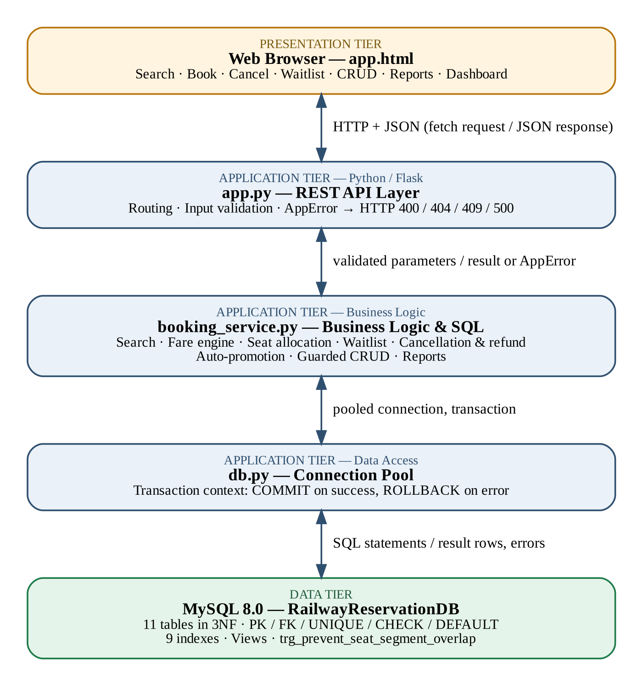
Figure 4.1: Three-tier system architecture
Presentation tier — app.html
The front end is a single web page with screens for searching trains, booking tickets, checking and cancelling PNRs, maintaining the waitlist, managing master data (trains, stations, passengers and schedules), and viewing reports and a dashboard. It communicates with the backend only by sending JSON requests over HTTP and displays any error messages returned by the server.

Application tier — app.py (API layer)
This module defines the REST endpoints, reads the request parameters, and calls the matching function in the business-logic module. It also handles errors uniformly: a typed AppError raised anywhere in the backend is converted into the correct HTTP status code — 400 for invalid input, 404 for a missing record, 409 for a conflict or blocked delete — and any unexpected exception is logged and returned as a 500 error in JSON format.

Application tier — booking_service.py (business logic)
All SQL statements and business rules are kept in this module. It contains the train search, the segment-aware availability calculation, the fare engine, seat allocation, waitlist handling, cancellation with refunds, automatic promotion, guarded CRUD operations and the reporting queries. Keeping all SQL in one place makes the logic easier to review and test.

Application tier — db.py (data access)
This module manages a pool of database connections and provides a context manager for transactions. Every unit of work runs inside it: if the work finishes successfully the transaction is committed, and if any exception is raised the transaction is rolled back automatically.

Data tier — MySQL 8.0
The RailwayReservationDB database stores eleven tables in 3NF together with their constraints, nine indexes, the overlap-prevention trigger, and the reporting views created in Review 2 (such as vw_SegmentSeatAvailability and vw_FinancialRevenueSummary).

4.2 Database Design and ER Model

The database contains eleven entities. Route_Stop resolves the many-to-many relationship between Train and Station and gives each stop an order. Schedule represents one run of a train on a particular date. Booking is the PNR header, and Journey_Segment links a booking to an exact seat for one station-to-station leg. Waitlist holds the FIFO queue, and Payment records the payments for each booking. Figure 4.2 shows the ER diagram with primary keys, foreign keys and the main attributes.
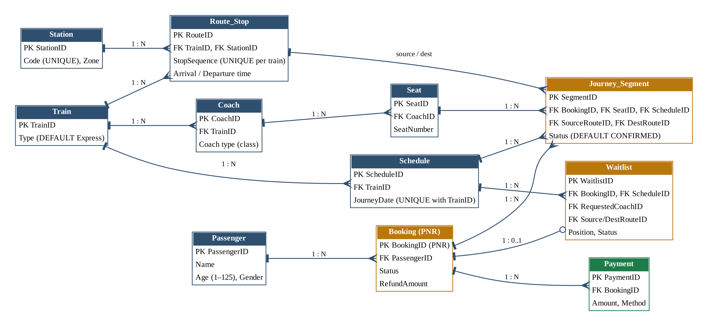
Figure 4.2: Entity-Relationship diagram
The main relationships are:
- Train 1–N Route_Stop N–1 Station (ordered stops for each train).
- Train 1–N Schedule (one row for each date the train runs).
- Train 1–N Coach 1–N Seat.
- Booking 1–N Journey_Segment (one PNR may cover several legs).
- Journey_Segment N–1 Seat and N–1 Schedule, and it refers to two Route_Stop rows (source and destination) that define the leg.
- Booking 1–N Payment, and Booking 1–0..1 Waitlist entry while the booking is not yet confirmed.

CHAPTER 5: SYSTEM WORKFLOW

5.1 Search, Fare Quote and Booking

Passenger types in origin, destination and date of travel. The inputs are first validated: all fields have to be filled out and origin must not be equal to the destination. For each train, the backend locates a pair of Route_Stop rows with the same Route_Id that have Origin and Destination columns with origin and destination strings in the correct order. For every coach class it tallies the number of seats that do not share a confirmed segment on that schedule and returns the corresponding trains with the actual number of seats on those trains.
The user interface sends a request to the server for a fare quote prior to making a booking. The distance, coach-type multiplier, age or quota discount, Tatkal surcharge and GST are applied on the server itself before calculating fare and the quoted fare and the final charge always match.
After the passenger confirms the booking the next steps execute within one transaction:
The passenger record and schedule for that train and date are searched or if not found are created.
2. The system looks for the seat in the class that is requested that has no conflict with the requested journey segments.
3. If a seat is found then Booking, Journey_Segment and Payment rows are inserted. The trigger will look at the segment once more when the segment is inserted.
If there is no seat available, the booking is booked as Waitlisted and a Waitlist row is created with next FIFO available seat, along with the requested coach and route.
Only if each step is successful, the transaction is committed, but if any step fails, the transaction is rolled back and the user is given a clear error message.

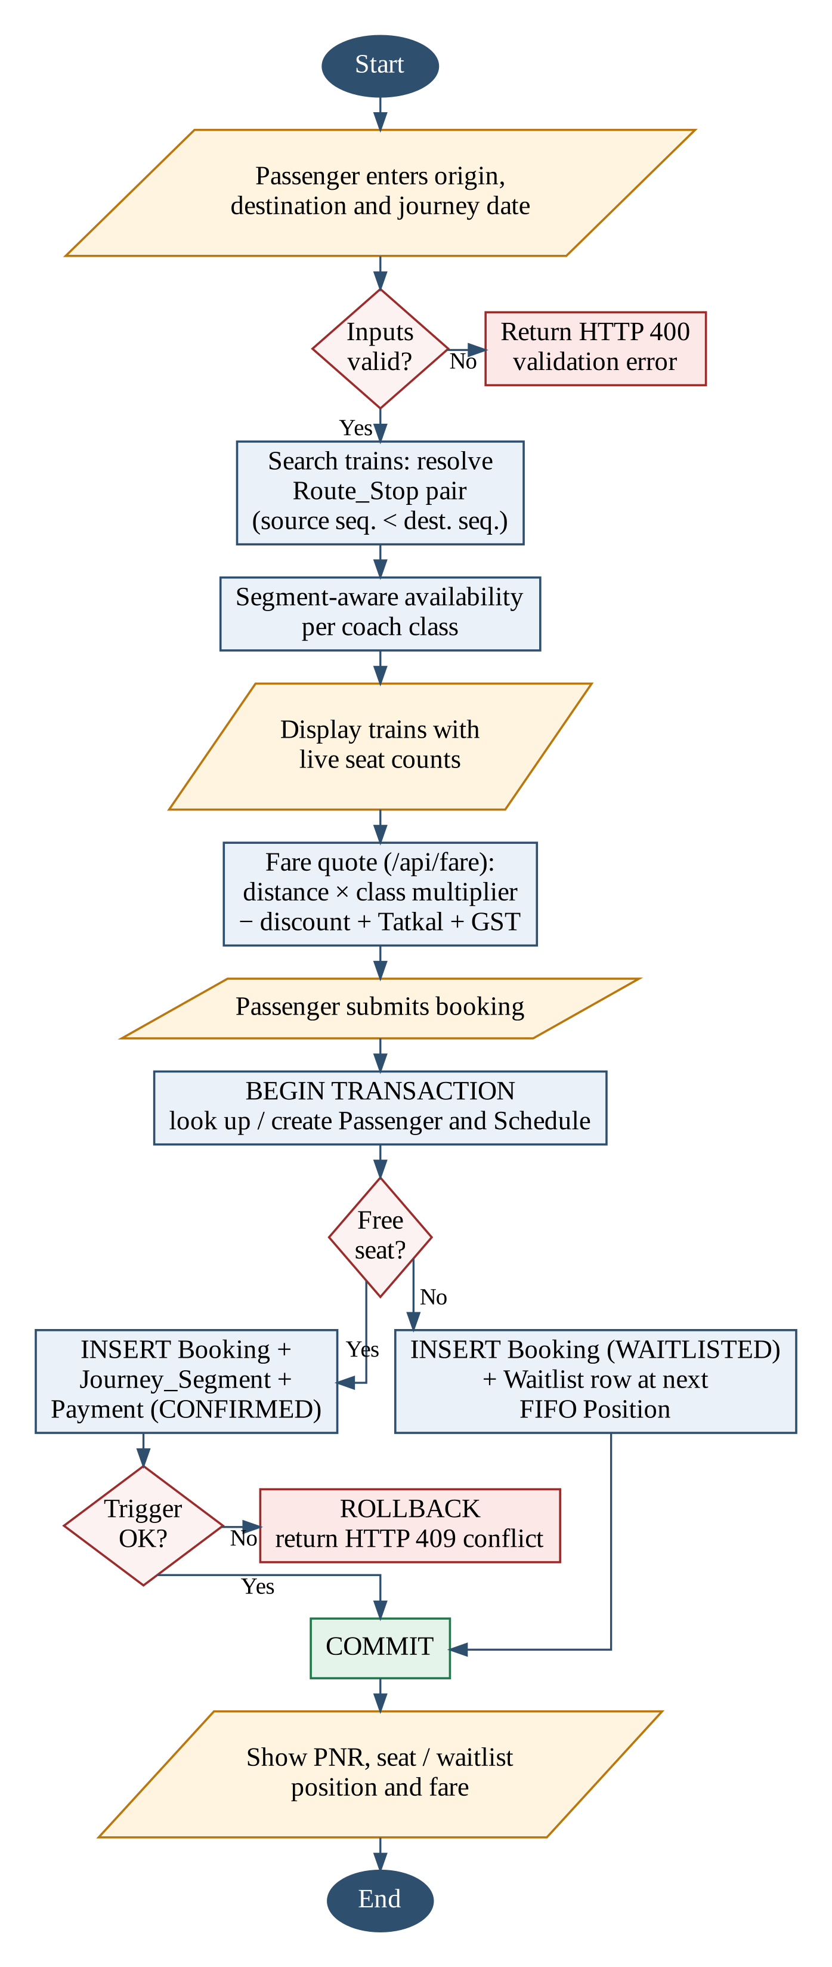
Figure 5.1: Flowchart — search, fare quote and booking

5.2 Cancellation and Automatic Waitlist Promotion
To cancel a ticket, user inputs the PNR. The system begins a transaction and locks the Booking row using the SQL SELECT...FOR UPDATE statement. If a PNR doesn't exist, it will return a 404 error, otherwise if the PNR has been cancelled, it will reject the request. Else the refund amount is calculated according to the tiered policy, the booking is cancelled, the refund amount is stored and the journey segments are cancelled.
If a confirmed seat is available, then it checks the wait list for that schedule in FIFO. The first passenger on the waiting list for the same class / segment that fits into the freed seat is automatically promoted: a journey segment is added to the freed seat, the booking is marked as confirmed and the remaining waiting list places are renumbered continuously. Any cancelled ticket that was also on a waitlist is removed and the waitlist is renumbered.

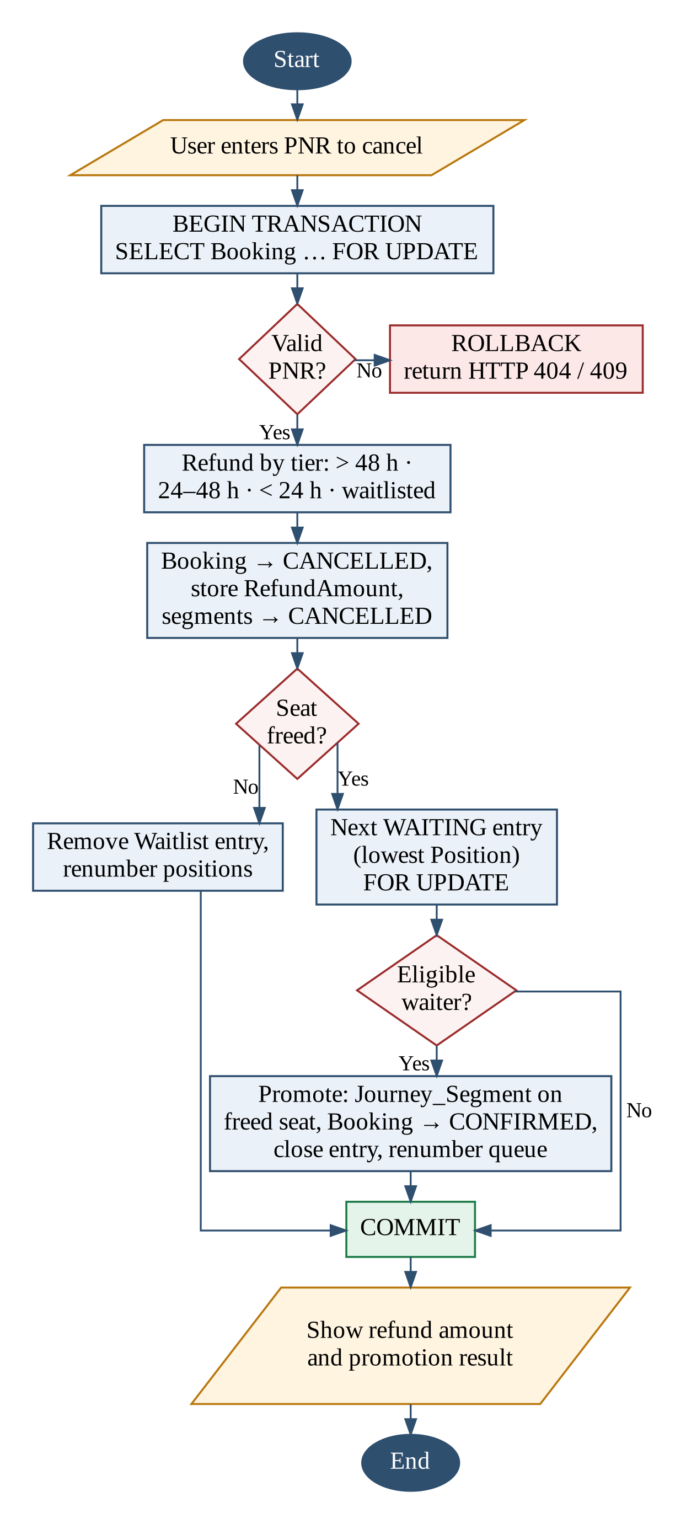
Figure 5.2: Flowchart — cancellation and automatic waitlist promotion

5.3 Waitlist Maintenance
The waitlist screen shows all waiting entries for each schedule in order of position. An administrator can promote a single entry, promote all eligible entries in one action, or cancel a waitlisted request. The remaining positions are then renumbered so the queue has no gaps.

5.4 Validation and Error Handling
Every endpoint validates its input before touching the database — required parameters, numeric types, distinct origin and destination, age limits and allowed status values. Problems are raised as a typed AppError, which app.py converts into the correct HTTP status code, as shown in Table 5.2. The user interface therefore always receives a structured JSON error, never a raw stack trace.

HTTP Status | Meaning in this System
400 Bad Request | Missing or invalid input (e.g. same origin and destination).
404 Not Found | Unknown PNR or record.
409 Conflict | Delete blocked by dependent records, or booking conflict.
500 Internal Server Error | Unexpected error; logged on server, JSON error returned.
Table 5.2: Error responses

CHAPTER 6: CONCLUSION

This project successfully developed a Railway Ticket Reservation and Journey Management System, taking it from a conceptual ER model to a fully working, database-backed application over three reviews. The schema was refined step by step and kept in Third Normal Form, and the most difficult rule of the domain — allowing one physical seat to be shared by several passengers on non-overlapping segments of the route — is enforced both in the booking logic and inside the database through a trigger, so that data correctness does not depend on the application alone. The final three-tier system, made up of a web front end, a Flask application layer and a live MySQL database, supports train search, segment-aware booking, waitlisting, cancellation with tiered refunds, automatic waitlist promotion, master data management and reporting, and is backed by integrity constraints, indexes, transactions with row locking, safe deletion rules, input validation, structured error handling and automated tests. Overall, the project demonstrates not only a working application but also the core database principles of normalisation, integrity, indexing and transaction management, and it provides a solid base for future enhancements such as seat-level locking, stored procedures, user authentication and online payments.

REFERENCES

- Indian Railways, “Revised Refund Rules,” Indian Railway Passenger Reservation Enquiry. [Online]. Available: https://www.indianrail.gov.in/enquiry/StaticPages/StaticEnquiry.jsp?StaticPage=refund_Rules.html&locale=en

- Python Software Foundation, “PEP 249: Python Database API Specification v2.0.” [Online]. Available: https://peps.python.org/pep-0249/

- [1] Press Information Bureau, Government of India, Ministry of Railways, “Computerized Rail Booking System,” Mar. 29, 2017. [Online]. Available: https://www.pib.gov.in/newsite/PrintRelease.aspx?lang=2&reg=48&relid=160137

